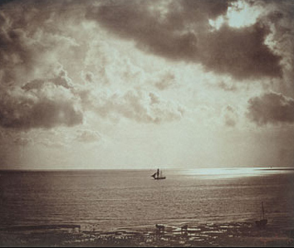
REGISTRATION FORM

Family name:...........................................................................................................................

Given name(s):................................................................ Sex: M F

Title: Prof. Dr. Young scientist (up to 30)

Institution:.........................................................................................................................

Position:............................................................................................................................

Mailing address:......................................................................................................................

Postal code and city:................................................................................................................

Country:.............................................................................................................................

Telephone:.....................................................FAX:...........................................................

e-mail:................................................................................................................................

Preference for............................... oral / poster presentation

Please, give the tentative title of your contribution

______________________________________________________________________

I would like to compete for SupraChem Award 2008 Yes No
(younger’s oral presentations only)

Accommodation Preference.......... single room / double room

Date

